KENYA

The Swahili word safari (literally, journey) would not mean much to most people if it wasn't for this East African adventure land. Revered by anthropologists as the 'cradle of humanity', Kenya is also the heart of African safari country, boasting the most diverse collection of wild animals on the continent.
Kenya promises the globe's most magnificent game parks, unsullied beaches, thriving coral reefs, memorable mountain scapes and ancient Swahili cities.

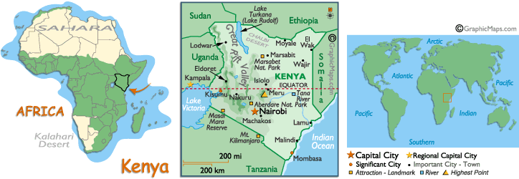

VISA
Visa on arrival is granted at USD 50 per person

INTERNATIONAL AIRPORTS:
There are two international airports in Kenya, Nairobi (NBO) and Mombasa (MBA)

FLIGHTS INTO KENYA:
From Mumbai, Kenyan Airways (KQ) flies daily into Nairobi. South African Airways flies via JNB or another option is Emirates via Dubai, which flies from different hubs like Del, Hyd, Blr, Ccu etc apart from Bom.

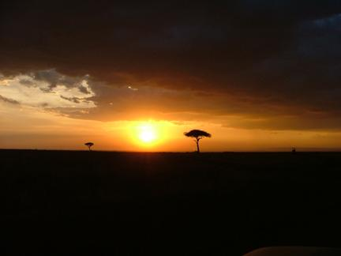

HOW TO GET AROUND IN KENYA:
By Air:
There are several small airline companies that offer domestic flights as well as the national airline, Kenya Airways. Destinations include: Amboseli, Kisumu, Lamu, Malindi, Masai Mara, Mombasa, Nanyuki, Nyeri, and Samburu. The smaller domestic airlines (Eagle Aviation, Air Kenya, African Express Airways) operate out of Nairobi's Wilson Airport.

By Train:
Kenyan trains are also a popular form of transport. The trains generally run on time and are considerably safer than travelling by bus or matatu. A passenger line runs inland from Mombassa to Nairobi, while another runs west from Nairobi to Kisumu.

By Taxis, Matatus, Tuk-Tuks:
Taxi's are numerous in the main cities and towns. Agree on the price before you get in since the meters are unlikely to work (if they have a meter to begin with).
Matatus are mini-buses that operate on set routes and passengers embark and disembark at whatever point they choose. Often colorful to look at but overcrowded and a little dangerous due to the drivers' love for speed.
Tuk-Tuks are also popular in Nairobi and are cheaper than taxi's. Tuk-Tuks are small three-wheeler vehicles.

CLIMATE:
Generally speaking, the dry months of July through October and mid-December through February are the best game viewing times in East Africa (Kenya, Tanzania and Uganda), when shorter grasses make animals easier to find.
It's also when Kenya's birdlife flocks to the Rift Valley lakes in the greatest numbers. June to September could be called the 'shoulder season’, as the weather is still dry. The rains hit from March to May (and to a lesser extent from October to December). During these months, things are much quieter - places tend to have rooms available and prices drop. The rains generally do not affect travellers' ability to get around. Heavy annual rains fall from late-March through May in East Africa and are good for observing calving, and for fresh green appearance and dust-free conditions. Just after the rains, June and early December are beautifully green and dust free.
Although Kenya straddles the equator, the climate is mild and pleasant with sunny days and temperatures averaging 80ºF (27 C) during the day and 55ºF (13 C) at night. The coastal areas are humid and you have the annual long rains from March to June and the short rains in October to November.

CURRENCY:
The Kenyan Shilling (KES) divided into 100 cents.
With the deregulation of the money supply, foreign exchange bureaus are the best places to change money. Their rates are competitive and they don't charge commission. Banks will change money, but their commission can be steep. US Dollars or Pounds Sterling are recommended. It is advisable to carry some US dollars cash in small denominations. Well known credit cards are accepted at many hotels and tourist shops.
The place to carry your money is in a pouch against your skin. Anything more obvious will only make a thief's job easier.

TIME:
Kenya is 2 hours 30 minutes behind India.

VOLTAGE:
Voltage throughout Africa is 220-240 AC and socket types vary. Bring with you an adaptor for appliances running on 110-120 U.S. Voltage. It is best to bring only battery operated appliances along if possible. Otherwise, an international converter and adaptor set, complete with a set of plugs is essential

LANGUAGE:
English is spoken throughout East and Southern Africa.
Swahili is the most widely spoken language in East and Central Africa

SECURITY:
Do not leave cash, travellers cheques or valuables unattended in your hotel rooms but use the hotel’s safety deposit boxes and avoid carrying large sums of money about. As with any large city, Nairobi has its share of con men and petty thieves; it is unwise to walk the streets after dark. It is advisable to only frequent international bars and nightclubs and travel by taxi.

HEALTH:
Inoculation against Yellow Fever is mandatory. It is imperative that anti-malarial prophylactics be taken before, during and after your visit. Changes of diet and water often cause mild stomach upsets, so a supply of anti-diarrhoea pills is advisable. Do not drink the tap water, but it is safe to use the water supplied in flasks in your hotel room and bottled mineral water is readily available.
Malaria protection is very important for travel to Africa.

CLOTHING AND EQUIPMENT:
It is recommended for both men and women that light, easy-care cotton be worn on safari. Comfortable pair of walking shoes or safari boots is a ‘must’, as is a hat, sunglasses, swimming costumes and a warm sweater. Although most places in Kenya are quite casual, it is advisable for men to include a jacket and tie.

Do bring a torch, binoculars, suntan creams, ample films and disposable razors, as shaving sockets are not available at all places outside the main centres. The main things to remember whilst packing are flexibility, versatility, and protection from the sun. For flexibility, travel with clothing that can be layered to adjust to temperature differences throughout the day. Versatility is important in helping you minimise the amount of clothing you bring.

Dress on safari is entirely casual, meaning jeans, shorts, T-shirts whatever you’re comfortable in. For visits to the Mount Kenya Safari Club, ladies/gentlemen require smart casual wear in the evenings. This will be useful for dining at better restaurants in the larger cities as well. For sun protection, bring a wide-brimmed hat, sunglasses and suntan lotion. Finally, bring a light windbreaker and sweater, and some comfortable footwear - sneakers are ideal.

TIPPING AND PORTERAGE:
Although hotels and lodges include a service charge, it is customary to tip porters, waiters, taxi drivers and safari drivers/guides.

LUGGAGE:
One normal sized suitcase and an overnight bag is the usual baggage allowance on most safaris. On internal charter flights only 15 Kgs of baggage is allowed.

PHOTOGRAPHY:
Avoid being discourteous to the local people by trying to "steal a photograph" - some tribes consider a camera to be evil and may try to attack if their photo is taken without permission. Your driver will seek permission for you and will negotiate the fee.
Your camera equipment should include a telephoto lens for photographing birds and wildlife; a 200mm lens is highly recommended. A standard 50mm lens and a wide-angle lens of 28mm are also recommended. Bring camera batteries and plenty of film, including a variety of types suitable for both low-light and bright-light photography. Sun filters may be useful, and a protective cover to shield your camera from dust. Video photography is also very popular among many but we suggest precautions against dust and rain.

AIRPORT TAX:
Airport tax is payable on departure from most international airports in Africa. This is usually payable in US Dollars

EVENTS:

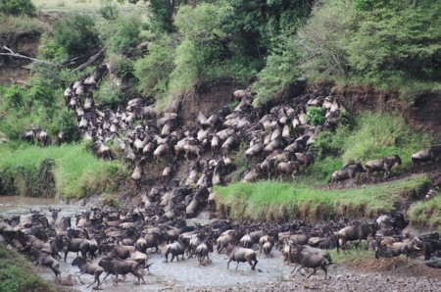

Kenya's most spectacular annual event is organised by an unlikely group - wildebeests. Literally millions of these ungainly antelopes move en masse in July and August from the Serengeti in search of lush grass. They head south again around October. The best place to see this phenomenon is at the Masai Mara National Reserve. Kenya's more orthodox annual events include public holidays such as Kenyatta Day (20 October) and Independence Day (12 December).

CITIES:

NAIROBI:
Kenya's capital is cosmopolitan, lively, interesting, pleasantly landscaped and a good place to get essential business matters sewn up. You can walk from one end of the central business district to the other in 20 minutes and it's a great place to tune into modern urban African life. A good base for travel in Kenya, from here excursions and safaris can be arranged to any of the national parks or reserves in the country.
Nairobi is best characterised by its variety of locally-given descriptive names, representative of the city's contrasting images - of wealthy spacious suburbs, charming flower-lined streets and a refreshing climate, alongside crime, corruption, filth and poverty. Names like 'Green City in the Sun', 'City of Flowers' and the Masai name 'Place of Cool Waters' attempt to overshadow the all too real version of 'Nairobbery' that stands as a well-found warning to newly arrived tourists.

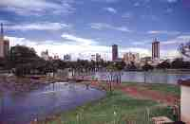

Nairobi is one of Africa's largest and most interesting cities. It is a place of enormous energy, a tireless and thriving bustle of people, and a city of differences. Assorted races, tribes and origins are all a part of its make-up. Kenyatta Avenue is the city's favourite tourist image, a broad avenue fringed by trees and flowers. There are several museums and places of interest in the centre, including the National Museum and Snake Park. There are numerous markets selling traditional crafts, especially the appealing Masai market. Just outside of the centre are the Nairobi National Park-Kenya’s first national park, and the nearby Bomas of Kenya host performances of traditional dancing and singing. The Langata Giraffe Centre offers visitors the chance to hand-feed the Rothschild giraffes that inhabit the area.

MUST SEES:

Nairobi National Park:
It is Kenya’s first national park. Uniquely situated on the capital’s doorstep it is a well-kept, compact and beautiful area of plains and wild bush containing a large number of Africa’s best-known animals. Large herds of zebra, wildebeest, buffalo and giraffe roam the plains and black rhino, ostrich, baboons, cheetah and lions are some of the other photogenic inhabitants. In the park is the Animal Orphanage where sick, wounded and abandoned animals are cared for and rehabilitated into the park, as well as an Educational Centre featuring a Safari Walk.

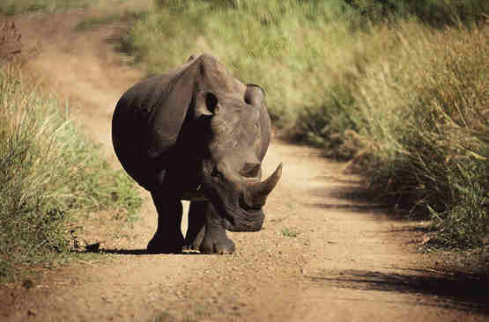

Recommended Hotels in Nairobi:
Panafric Hotel
Serena
Nairobi Safari Club
Holiday Inn Nairobi
Intercontinental Hotel
The Stanley Hotel

MOMBASA:
The coastal town of Mombasa is the second largest city in Kenya. Located in the South-Eastern part of Kenya, it plays an important role in the country’s economy, not only for its imports and exports through its port-which is the largest in East Africa, but also as a destination for tourists visiting Kenya.

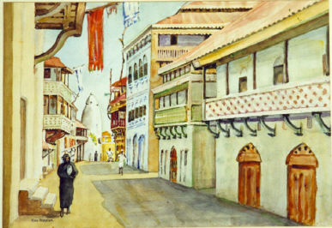

Mombasa undoubtedly has one of the best white sandy beaches and coral reefs that Africa has to offer. Coupled with an array of hotels on the beachfront situated along the North and South coasts of the town, it characterizes Mombasa as the ideal place for a vacation
Apart from the beautiful beaches, another unique aspect of this wonderful town is its rich history. The “Old Town” is reminiscent of the days when the Portuguese used to rule Mombasa, and you can experience the history even today in the structures that still stand, such as the Fort Jesus. The town is heavily influenced by Arabic culture, and is more observable here than in other parts of the town.
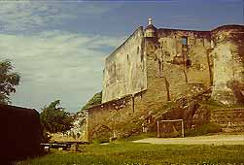

Fort Jesus is Mombasa’s most popular tourist attraction. The fort, located along the coastline near the Old Town, is a monumental piece of architecture that was built in the 16th century by the Portuguese. The fort opens its gates for viewing in the morning and closes at dusk

The Mombasa "Tusks" are symbolic representations of entrance into the heart of the town. The tusks were built to commemorate the visit of Queen Elizabeth to the town in 1952, as they lay directly on the path from the port to the town. Ivory was considered to be an exquisite commodity during the time, and in essence the tusks were meant to embrace the Queen and the British Empire into the town and within its social structure. Coincidentally the tusks also spell the letter "M" for Mombasa

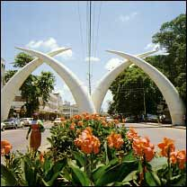

The Hindu temple is a one of the many symbols of Mombasa's cultural diversity
Mamba Village, which is situated in Nyali, is East Africa’s largest crocodile farm. A tour of the farm starts with a movie on the life cycle and behaviour of crocodiles, followed by a comprehensive tour of the rest of farm, and ends with the highlight of the day: a spectacular scene of blood-thirsty crocodiles fighting for food during feeding time. Excellent cuisine is available at the Mamba Restaurant, and the house specialty is superbly grilled crocodile meat. Souvenirs of your visit can be bought at the Mamba Souvenir shop located within the village.
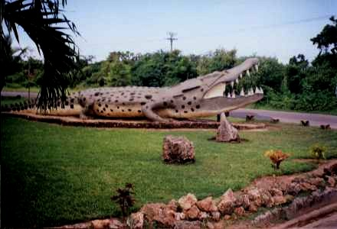

The Bamburi Nature Trail is the largest animal sanctuary in Mombasa. The Nature Trail boasts an enormous variety of animals, reptiles, insects and botanical gardens. Walking along the trail is the ideal way to look at the various animals, and on many occasions, holding or feeding a reptile such as a snake is allowed under close supervision of a guide.

Mombasa has many hotels situated along its white sandy beaches as well as in the heart of town. The best hotels can be found along the North Coast, where hotel rooms are just yards away from the warm sandy beaches. Most of the newer hotels are situated on the South Coast and further along the North Coast.
Recommended Hotels in Mombasa:
Indian Ocean Beach Club
Lagoon Reef Hotel
Leopard Beach
Ocean Village
Golden Beach Hotel

MASAI MARA NATIONAL RESERVE:
The Masai Mara National Reserve lies about 270 km from Nairobi, and takes about 4 to 5 hours by road. There are scheduled flights, twice daily from Wilson Airport Nairobi, which take about 40 - 45 minutes.

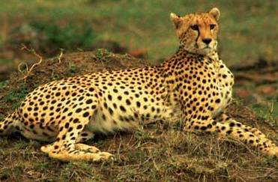

The Masai Mara is in southwestern Kenya on the border of Tanzania. The reserve is situated in the Rift Valley with Tanzania's Serengeti Plains running along its southern end. The Mara River runs through the reserve (north to south) hosting plenty of hippos and crocodiles and making the annual migration of over a million wildebeest and hundreds of thousands of zebras.

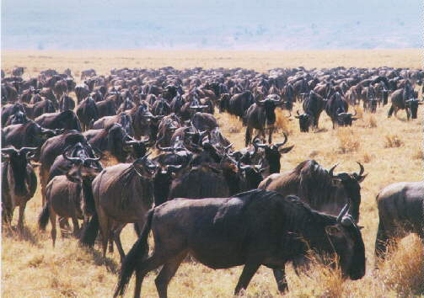

The Mara (as the old hands like to call it) is the most popular game park in Kenya. Abounding with wildlife and taking in a vast slab of the Serengeti, this 320-sq-km reserve is anything but plain. Few visitors miss roaming at least part of its vast open grasslands - or leaping out of the way of the yearly wildebeest stampede. The western border of the park is the spectacular Esoit Olooloo (Siria) Escarpment and it's at the edge of the park that the concentrations of game are the highest. Lions are found in large prides everywhere and it's not unusual to see them hunting. Elephants, buffaloes, zebras and hippos also exist in large numbers. A reserve rather than a national park (the Maasai people are allowed to graze and hunt animals here), the Mara includes a Maasai village that is open to tourists.
The small provincial town of Narok - a few hours drive west of Nairobi - is the park's main access point.

Activities at Masai Mara
Game Drives: If you have flown straight to the Masai Mara Reserve then your safari package will usually include several daily game drives. If you have rented your own vehicle then it is recommended you take an askari (guard) with you.
Walking Safaris: If you enjoy a little adventure try a walking safari with a Maasai guide.The best ones are outside the reserve boundaries.
Cultural Tours with the Maasai: Visiting a traditional Maasai village or enkang is frequently included in a safari package to the Masai Mara.
Hot Air Ballooning: is a popular pastime that provides an expensive but unique experience. Every lodge and camp will be able to set up a flight for you. The balloons usually fly at dawn and last about an hour. Upon landing most balloon companies, offer a champagne breakfast.

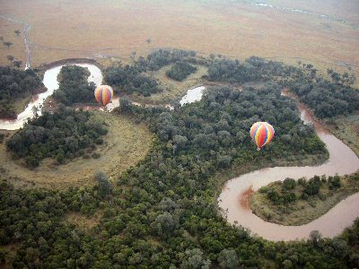

Recommended Accommodation in Masai Mara
Mara Serena Lodge
Keekorok Lodge
Mara Simba Lodge.
Mara Sopa Lodge

LAKE NAKURU:
Lake Nakuru located in Central Kenya, 140km north-west of Nairobi, in Nakuru District of the Rift Valley Province is a very shallow strongly alkaline lake covering an area of 188 km2. It is set in a picturesque landscape of surrounding woodland and grassland next to Nakuru town. The landscape includes areas of marsh and grasslands alternating with rocky cliffs and outcrops, stretches of acacia woodland and rocky hillsides covered with a Euphorbia forest on the eastern perimeter.

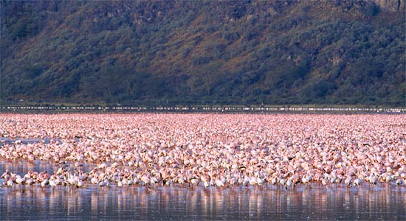

The lake catchment is bounded by Menengai crater to the north, the Bahati hills to the north east, the lion hill ranges to the east, eburu crater to the south and the mau escarpment to the west. Three major rivers, the Njoro, Makalia and Enderit drain into the lake, together with treated water from the town's sewage works and the outflow from several springs along the shore.
Lake Nakuru was first gazetted as a bird sanctuary in 1960 and upgraded to National Park status in 1968.
How To Get There:
Roads:
The park has a tarmac road connection with Nairobi, a distance of 156 km north west of Nairobi on the main A104 road. The most commonly used route into the park is via the main gate, 4 km from Nakuru Town Centre. It is also possible to enter the park from the main Nairobi Nakuru road at Lanet Gate. The Nderit Gate is used by people accessing the park from Masai Mara or Elementaita.
Must Sees in Lake Nakuru:
Flamingoes (Greater and Lesser) and other water birds including a variety of terrestrial birds numbering about 450 species in total.
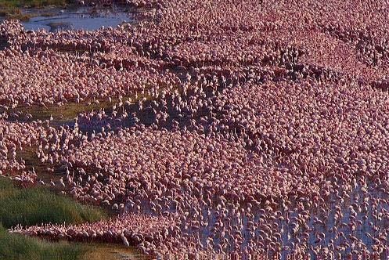

Mammals: 56 different species including white rhinos.
View-points: Lion hill, Baboon cliff and Out of Africa
Hills: Enasoit, Honeymoon, Lion hill ridge etc.
Waterfalls: Makalia
Unique vegetation: About 550 different plant species including the unique and biggest euphorbia forest in Africa, Picturesque landscape and yellow acacia woodlands.
Recommended Accommodation in Lake Nakuru:
Lake Nakuru lodge
Sarova Lion Hill Lodge.
Naishi Guest House
Kina Luxury Banda

AMBOSELI NATIONAL PARK:
At 392 sq. km, Amboseli is not a large park but it does offer you the best chance of seeing the endangered black rhino. It also has huge herds of elephants, and to see a herd of them making their way sedately across the grassy plains, with Tanzania's Mt Kilimanjaro in the background, may be a real African cliché but it's an experience, which certainly leaves a lasting impression. Microlight flights are a popular way to take in the majesty of this spectacular southern region of Kenya. Most visitors approach Amboseli through Namanga, the main border post between Kenya and Tanzania. There are also daily flights from Nairobi.

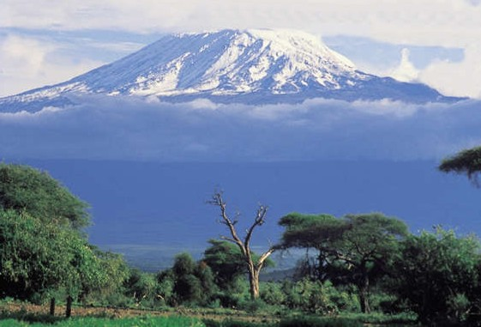

A wildife safari into Amboseli lets the visitor enter the majestic realm of the Elephant. This beautiful park consists of wide-open plains crowned by the snow-capped peak of Kilimanjaro.
The most obvious resident are the large elephant herds, and they are impossible to miss. Elephants are a continual presence throughout the park, and this provides plenty of opportunities to observe and learn from a wide variety of their social behaviour. With a well-trained guide, it is easy to understand and follow the social heirachy of each herd, and their constant social interaction.
The open plains attract plenty of grazing game including zebra, wildebeest, and impala.
Cheetah are often seen here, either hunting on the plains or at rest in the undergrowth.
The best time to see game in Amboseli is early morning and late afternoon. In the midday heat, Elephants and other animals retreat to the cool of thick undergrowth and can become invisible. Morning and afternoon game drives also allow you to witness the unforgettable African dawn and sunsets.
The most common means of Game viewing here is in customized vehicles, with open topped roofs or sides ideal for photography. Game can be seen from some of the lodges and camps.
Guided game walks are possible on the fringes of the park, and to the high observation point within the park. These can be arranged at most camps and lodges. This is a great way to experience the bush at its best.

ABERDARE NATIONAL PARK:
This park essentially encloses the moorland and high forest of the 60km-long Kinangop plateau. Only rarely does this place feature in the itineraries of safari companies and individual travellers visit it even less. However, if you're willing to brave the inclement weather, this remote and formidably dense forest is well worth the effort. The park offers a variety of fauna, flora and scenery, which you won't find elsewhere except, perhaps, on Mt Kenya. There are also the dramatic Gura Falls, which drop a full 300m, along with alpine moorland, and the slim chance of seeing a black leopard, elephant, rhino or bongo (rare spiral-horned antelope).

THINGS TO BE KEPT IN MIND:
A 7 seater coach is always non AC.

SAFARI DO'S AND DON'TS:

DO'S
- Do wear muted or neutral colours, like khaki, tan or beige.
- 4 x4 land cruiser is always recommended.
- Do move slowly and fluidly in the vehicle, minimizing sudden movements.
- Do encourage your driver to move the vehicle as little as possible and to drive slowly, respecting the personal space of the animals.
- Do encourage your driver to turn off the engine in the presence of animals and not to rev the engine when starting or to attract the attention of the animals.
- Do refrain from smoking
- Do avoid walking after 6.30pm in the city. Preferably, take a taxi.
- Do drink mineral water or bottled water

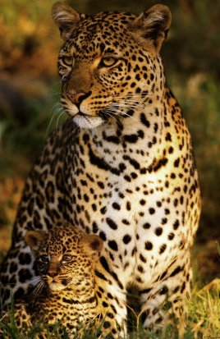

DON'TS
- Don’t wear brightly coloured or high contrast clothing
- Don't wave.
- Don't throw anything out of the vehicle
- Don't speak above a whisper
- Don't yell at the animals
- Don't pound your hands on the side of the vehicles or clap hands in order to get the attention of or scare the animals
- Don't feed the animals
- Don't leave any valuables in the vehicle or in your hotel room, keep in the safety deposit at the Hotel / Lodge / Camp
- Don't wear expensive jewellery during the day around the city
- Don't drink tap water
- Don't photograph tribes, if photos are required, seek driver's advice.
- Don't carry excess baggage.

INDIAN RESTAURANTS:

Mombasa
Mombasa
Shenai
Blue room

Nairobi
Anghiti Restaurant
Rhapta Road, Westlands
44 12 58
Bhandini Restaurant,
Inter-continental hotel
23 2 00 00 00
Bhatia,
General Mathenge Road, Peponi
58 22 97
Chowpaty,
Shimmers Plaza, Westlands
44 35 27
Haandi Restaurant,
The Mall, Westlands
44 82 94
Open House Restaurant,
Mpaka Road, Westlands
3 74 58 24
Sitar Restaurant,
Grand Regency Hotel
21 11 99

SHOPPING:
Wood Carvings are plentiful throughout the continent and range in price from a few dollars to several hundred dollars, especially the now famous Makonde carvings, originating from Tanzania. Spears and shields, local handicrafts, bead work screen printed fabrics are common. There is a wide variety of carving styles using a range of materials available. It is well worth shopping around for quality and value. Carvings are probably the most popular item with visitors to Kenya. On the coast carving of ornate doors, furniture and household fittings play a major part in local culture. The best carvers are found on Lamu, where they produce excellent chairs, doors, brass inlaid boxes, picture frames and small replica dhows.
One of the most popular is the sisal basket called the Kiondoo. These baskets commonly produced in Kikuyu areas are a small functional basket with a leather-carrying strap. They are popularly used as handbags.
The beaded jewellery and decorative items of the Masai has become internationally famous. The beadwork is astonishingly intricate and beautiful, combining thousands of tiny coloured beads with cowrie shells and leatherwork.
Bargaining is the expected norm in Markets and even in some shops throughout Kenya.

